Med Pharm

A PROJECT REPORT

Submitted by

DHRUV PATEL
KISHAN PATEL

In fulfillment for the award of the degree
of
BACHELOR OF ENGINEERING
in
Information Technology

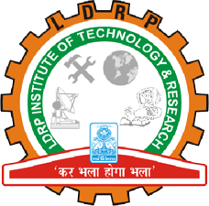

LDRP Institute of Technology and Research, Gandhinagar
Kadi Sarva Vishwavidyalaya
April/May, 2017

LDRP Institute of Technology and Research
Gandhinagar

CE-IT Department
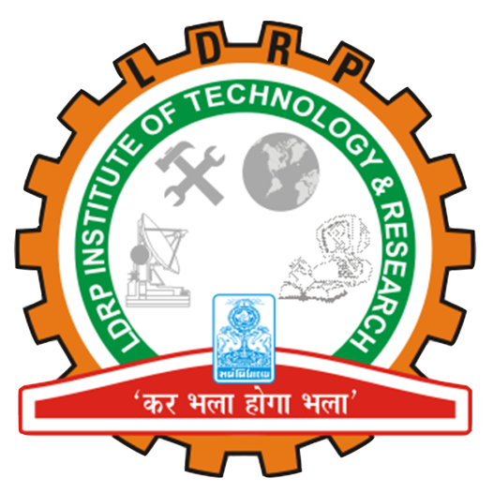

CERTIFICATE
This is to certify that the Project Work entitled “Med Pharm” has been carried out by Dhruv Patel (1317BEIT30014) under my guidance in fulfilment of the degree of Bachelor of Engineering in Information Technology (8th Semester) of Kadi Sarva Vishwavidyalaya University during the academic year 2016-17.

Prof. Jalpa Khamar Prof. Abhinay Pandya
Internal Guide Head of the Department
LDRP ITR LDRP ITR

LDRP Institute of Technology and Research
Gandhinagar

CE-IT Department

CERTIFICATE
This is to certify that the Project Work entitled “Med Pharm” has been carried out by Kishan Patel (1317BEIT30029) under my guidance in fulfilment of the degree of Bachelor of Engineering in Information Technology (8th Semester) of Kadi Sarva Vishwavidyalaya University during the academic year 2016-17.

Prof. Jalpa Khamar Prof. Abhinay Pandya
Internal Guide Head of the Department
LDRP ITR LDRP ITR

